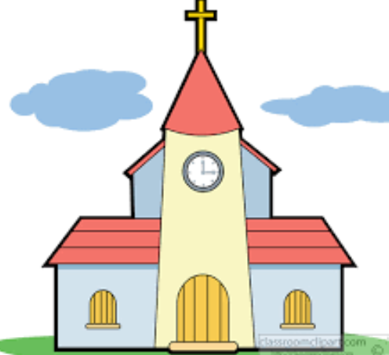
Personal Social and Emotional Development
I will learn to…
name and describe people who are familiar to me
know when to take turns
identify and express my own feelings
be confident to try new activities and show independence
khow good manners, please, thank you
give eye contact
work and play cooperatively
be able to wait for what I want
know right from wrong
Physical Development
I will learn to…
move safely, running , jumping, crawling, walking, hopping, skipping and climbing
be honest, understand fair play, show confidence and perseverance
negotiate space and obstacles safely
demonstrate strength, balance and coordination when playing
become increasingly independent in getting changed
use developmental writing in my play
use one handed tools e.g. scissors, paintbrush and cutlery
hold a pencil effectively
show accuracy and care when drawing
use core muscle strength to achieve a good posture when sitting at a table or sitting on the floor
know that exercise is good for me
know the importance of healthy eating

EYFS Learning Organiser Autumn 1 2025 Marvellous Me and Magical Rhymes

Enrichment Opportunities

Nursery Rhyme Character dressing up day and nursery rhyme challenge
(Thursday 23rd October)

R.E. will learn to…..
participate in assembly time through listening, singing and discussions
know that God is a name and that Christians believe God made the world
know I can be a creator too
know how Christians say thank you to God
consider what I am thankful for

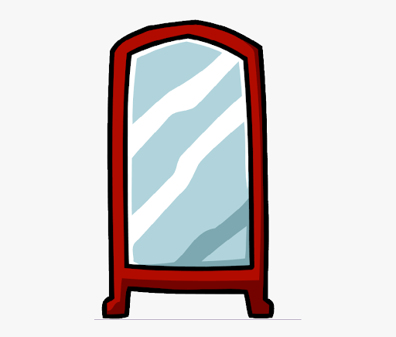

Autumn 1
Marvellous Me and Magical Rhymes

Communication & Language
I will learn to…
understand how to listen carefully and why listening is important to learn new vocabulary
develop social phrases
engage in storytime
learn rhymes, poems and songs
think out loud to work things out

Pamphill Values

Shine like stars in the sky as they hold onto the word of life

Philippians 2:15

Generosity

Prime Areas

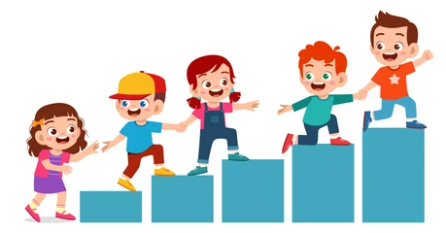


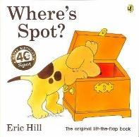
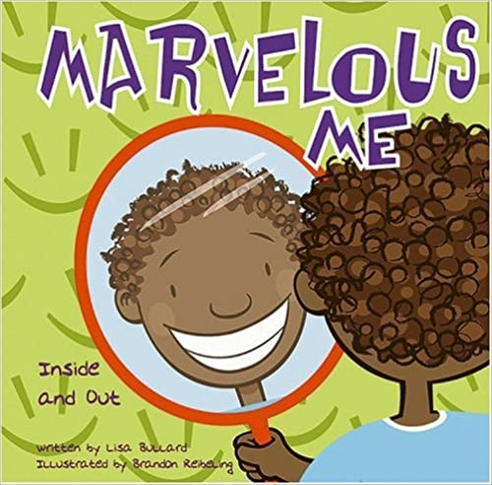
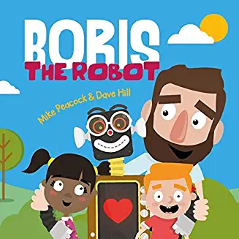
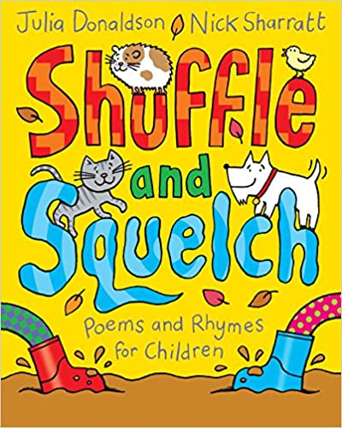
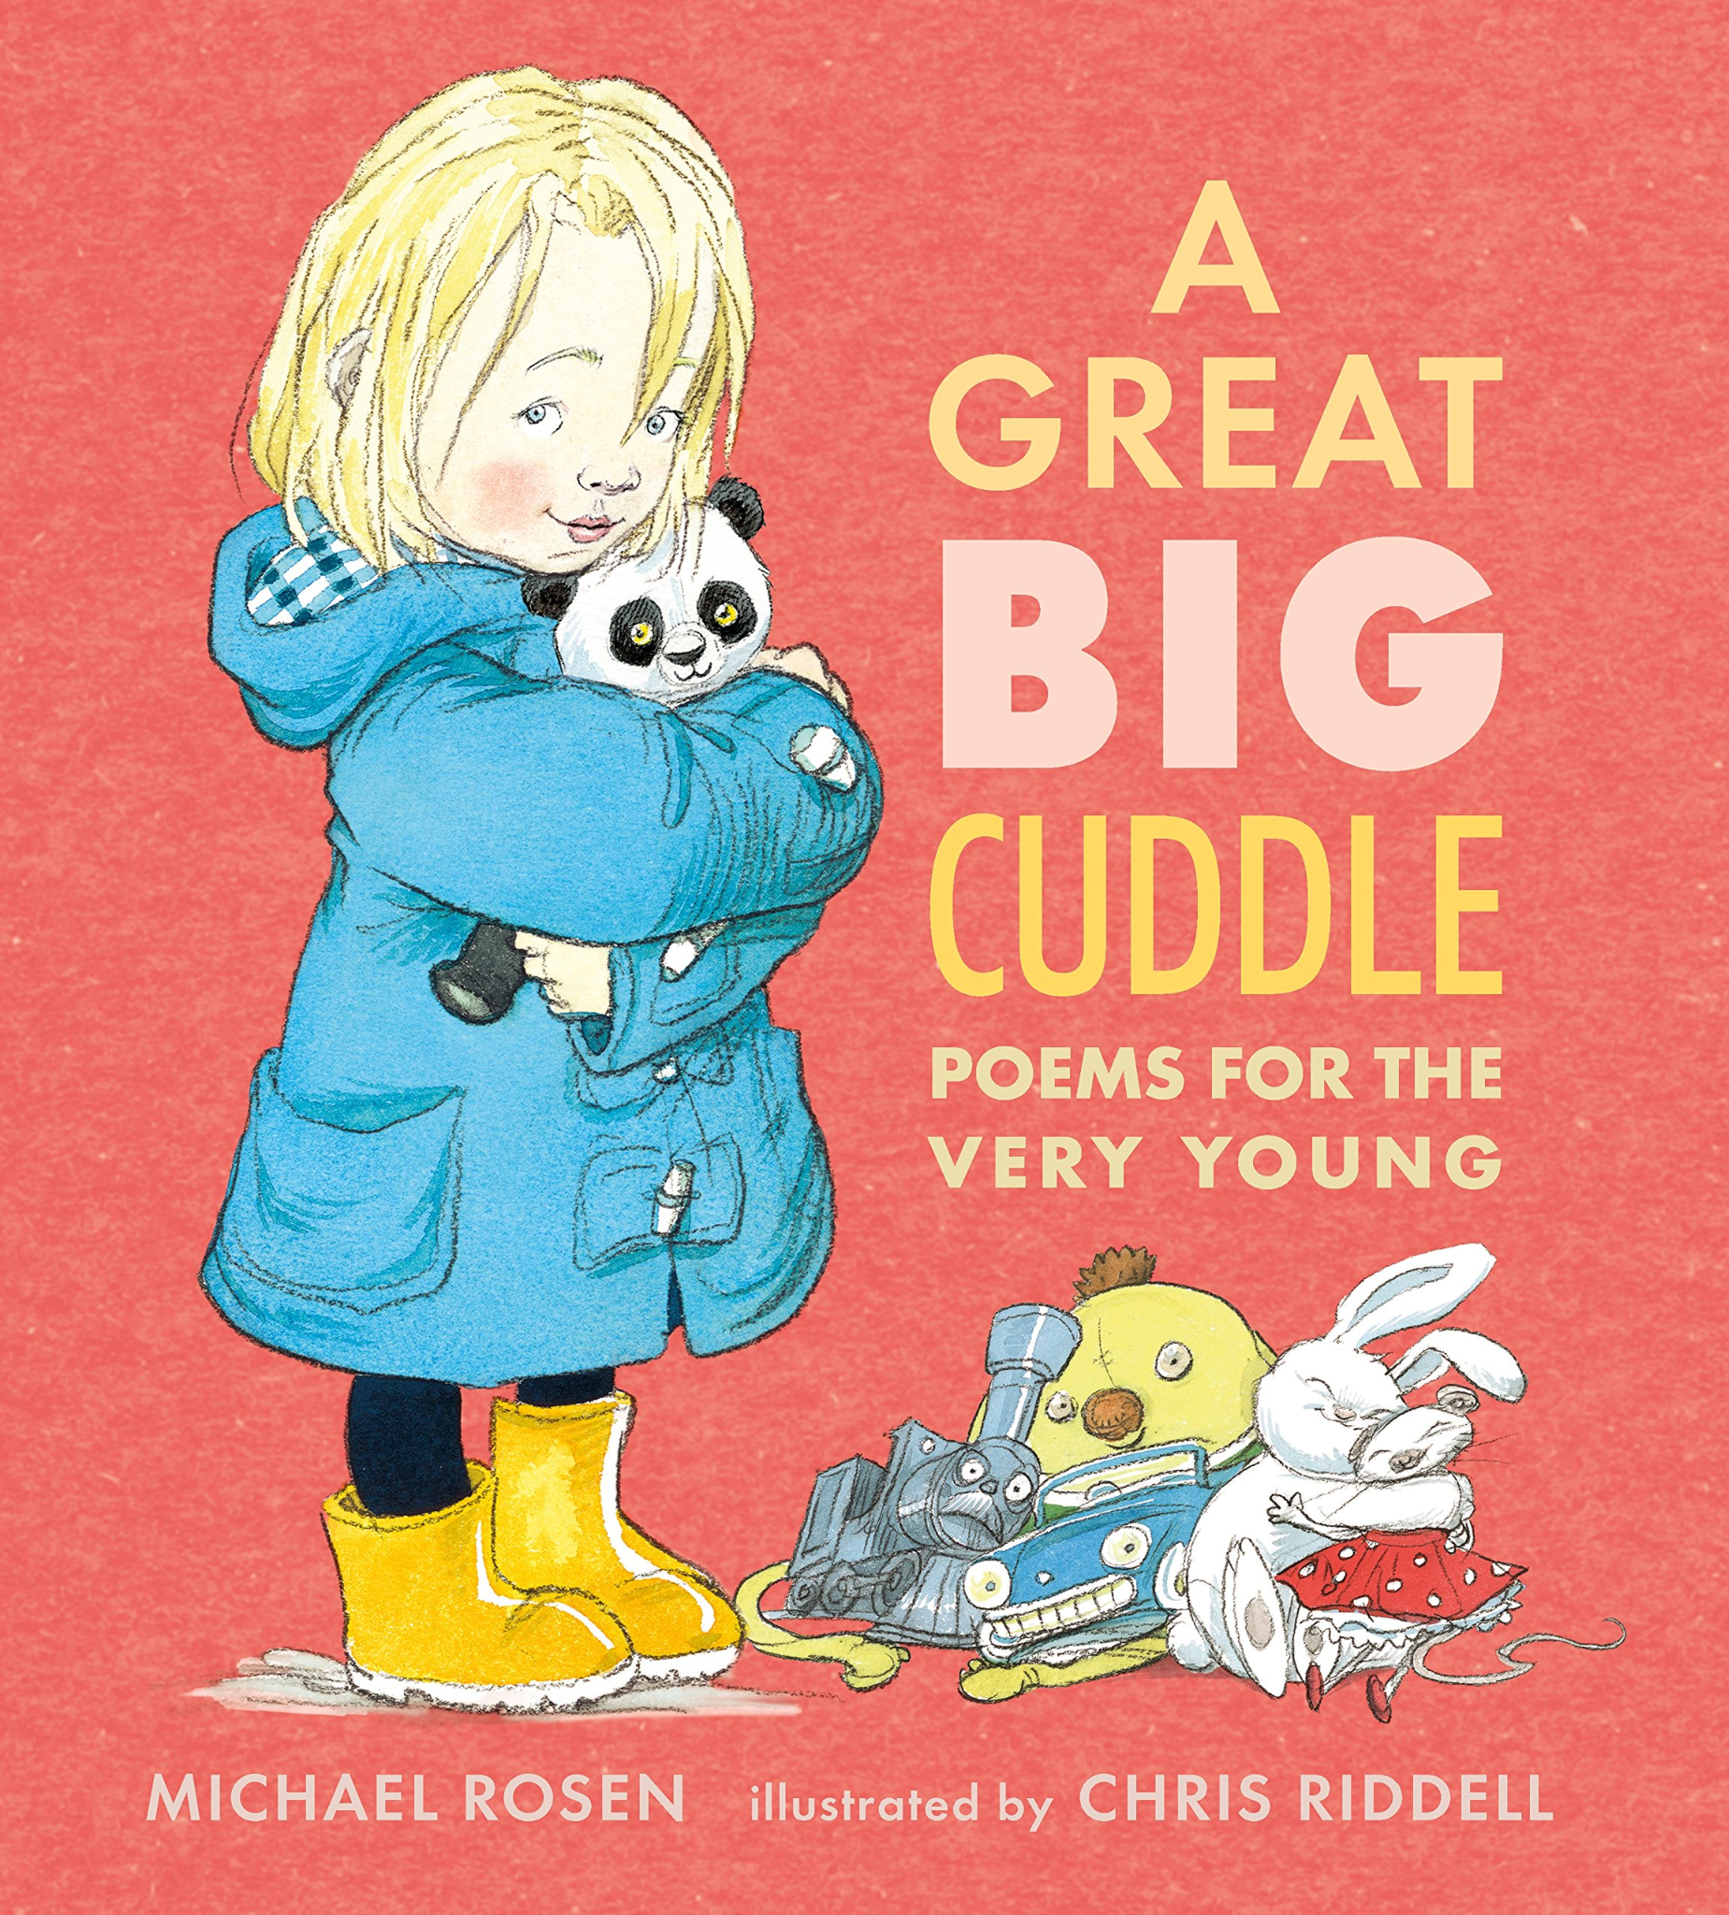
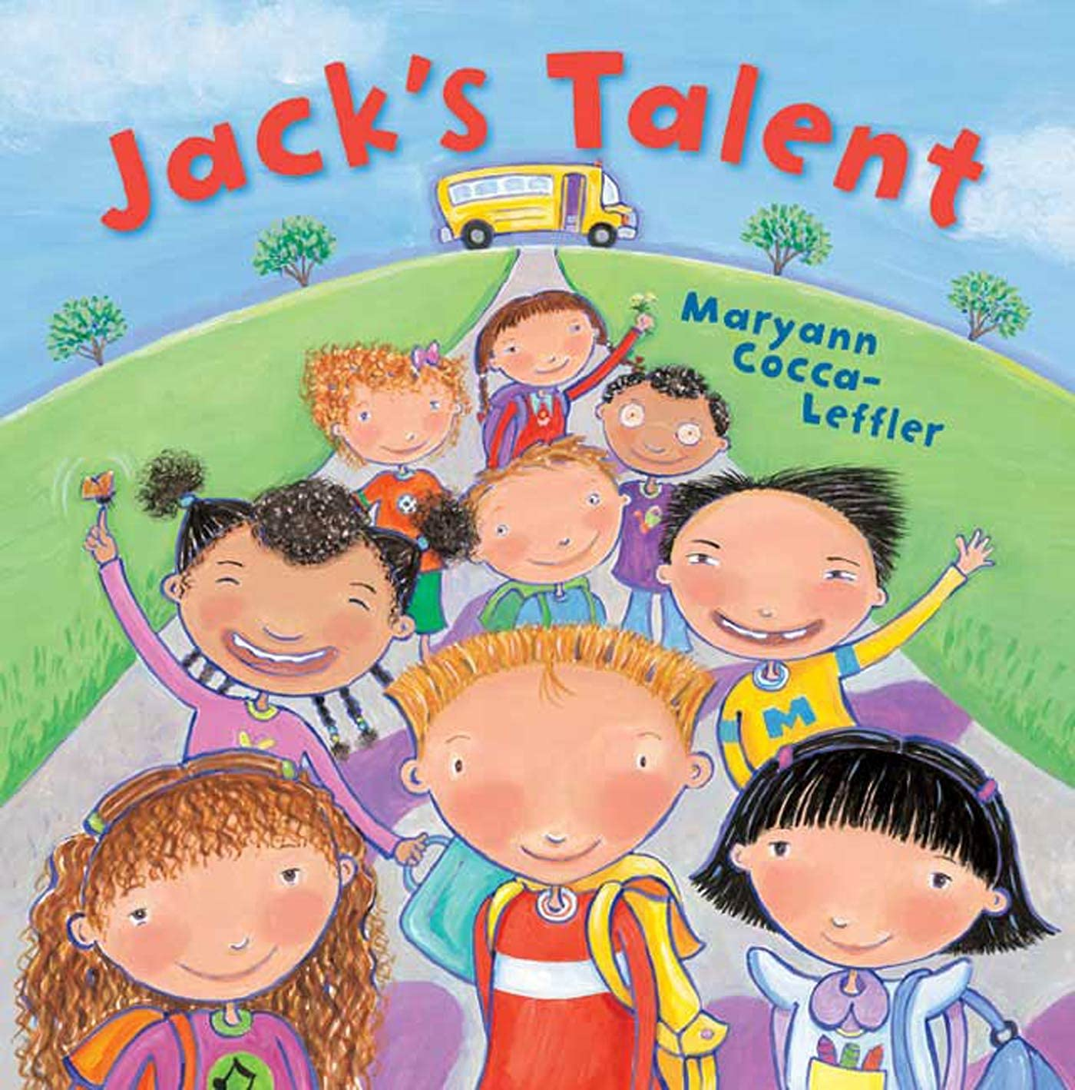
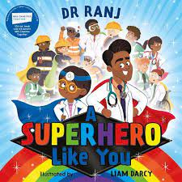
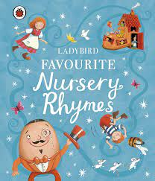
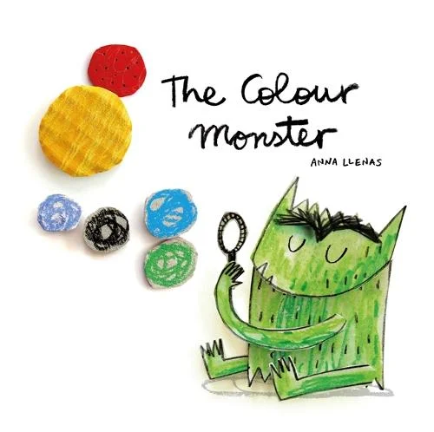
Literacy
I will learn to…
recognise and write my own name
write a label or phrase
understand the title tells me something about the book
identify parts of stories and words I do not understand and ask for clarification
anticipate key events in stories
infer character feelings
read individual letters by saying the sounds for them
have a good posture when sitting at a table or on the floor/ lying on the floor
hold a pencil in tripod grip in preparation for fluent writing

Key Texts

Specific Areas

Maths I will learn to…
use the classroom timetable
match (same/identical/different)
sort in different ways
compare amounts using key language
copy, continue and create simple repeating patterns
explore size, mass and capacity
explore, subitise and represent 1,2,3

Expressive Arts and Design
I will learn to…
make representations of what is seen
explore, use and refine a variety of artistic effects
work with others to develop creative ideas
mix two colours to make another colour
share creations explaining processes used
use and explore materials tools and techniques
make props for role play
join in with singing songs and nursery rhymes

Understanding some ways that we can play our part and care for our bit of The World
Topic related language
Marvellous, unique, courage, appearance, feelings, family, rules, talent, manners, similar, different, weather, seasons, autumn, road, town, country, natural, manmade, past, present, The Green, school, hill, church, shadow, transparent, portrait, values

Understanding the world
I will learn to…
understand what the past and present are
know some jobs that people do
know what family and friends are
make observations about the changing weather and seasons
know that Pamphill is a place and what it is like in this place
explore the natural world around me during hands-on experiences
explore shadows



